CITIES AND STATES | We're looking for the US State the city is in.  There will be some where there are multiple cities of the same name, we're looking for the most populous one.

1 | Manchester
2 | St Louis
3 | Cincinatti
4 | Baltimore
5 | Seattle
6 | Milwaukee
7 | Wichita
8 | Tulsa
9 | Mobile
10 | Kansas City

NATIONAL FLAGS |  | 1  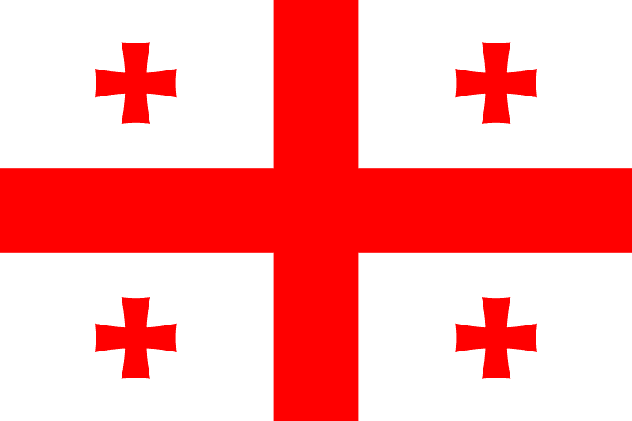.
2  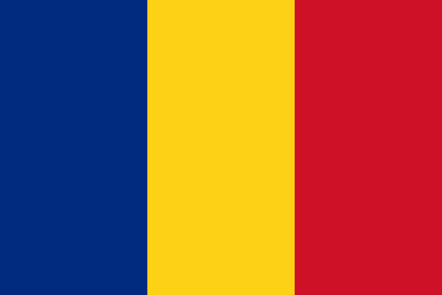 | 3  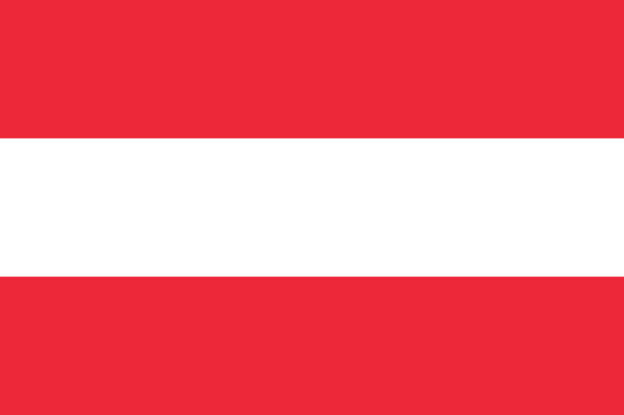 | 4  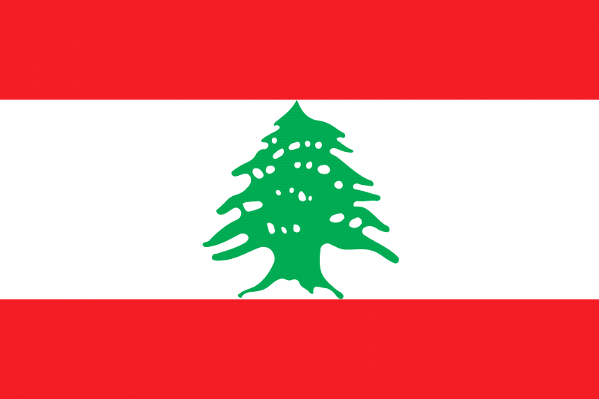
5  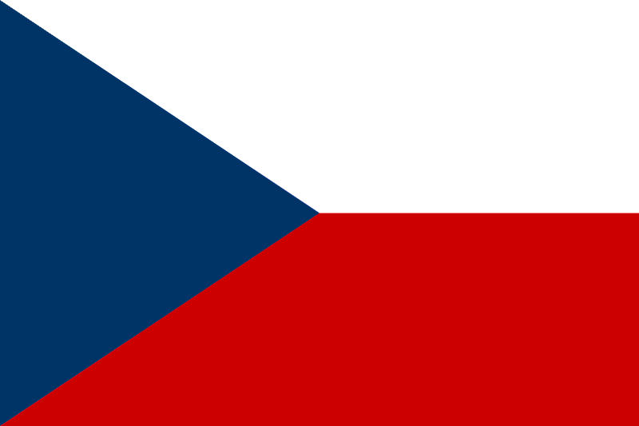 | 6  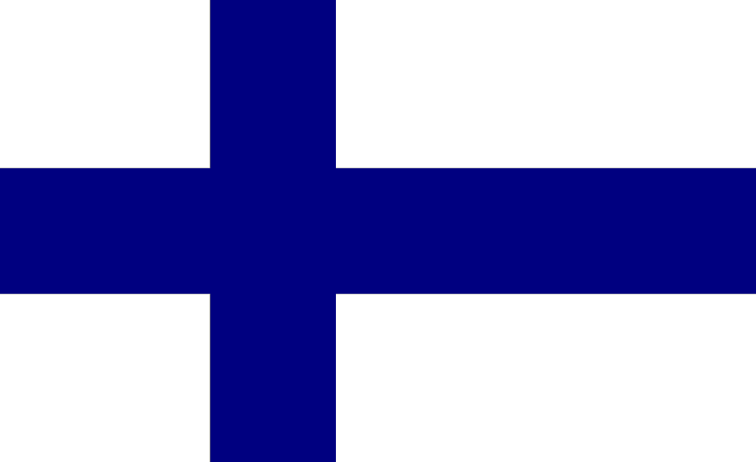 | 7  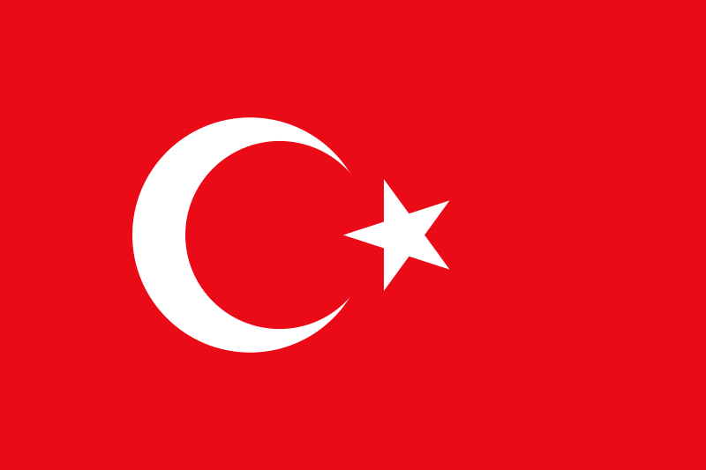
8  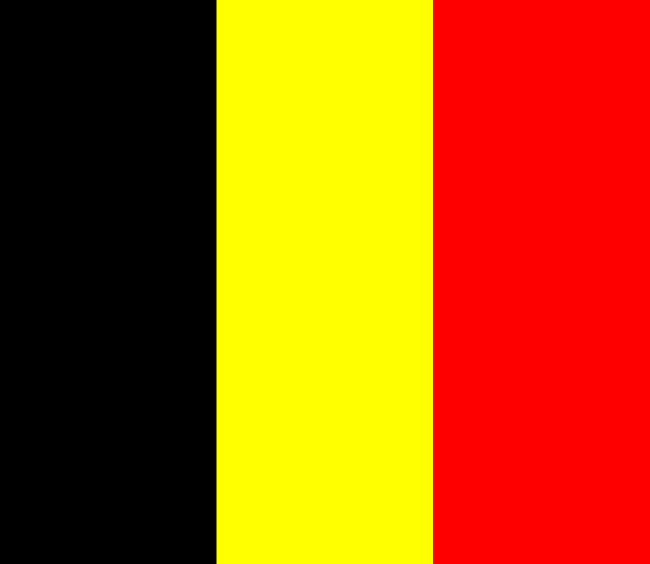 | 9  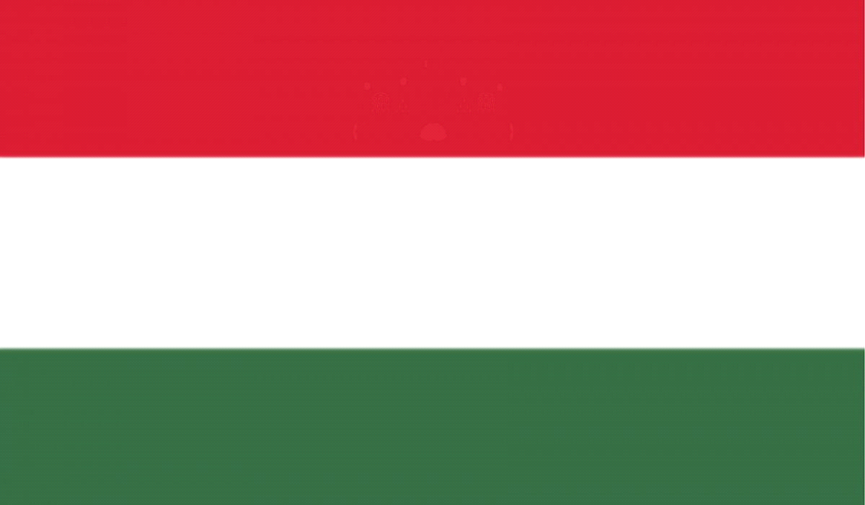 | 10  