MULTIPLE CHOICE WHICH IS THE CORRECT MEANING FOR EACH ROAD SIGN |  | 1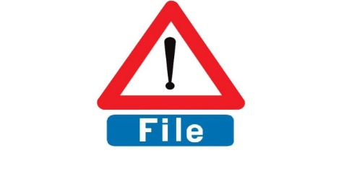  BELGIUM - Traffic queues likely ahead
2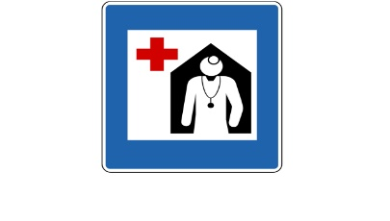  NORWAY- Hospital | 3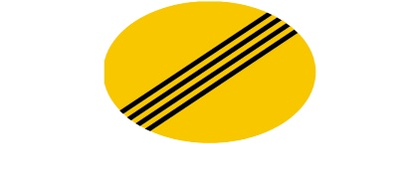  ICELAND- End of all restrictions | 4  ESTONIA -Bus Lane
5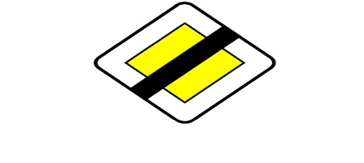  SPAIN – End of priority. | 6  Spain –Give way sign ahead, | 7  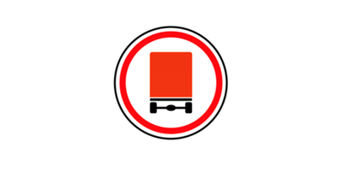  RUSSIA- Vehicles carrying dangerous goods prohibited,
8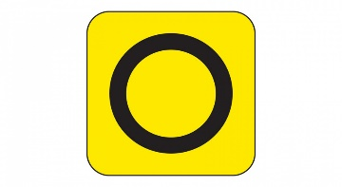  UK-Emergency diversion route | 9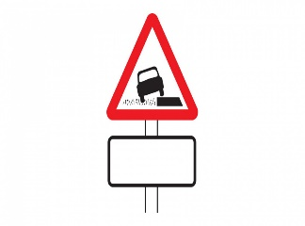  UK –Soft Verges. | 10  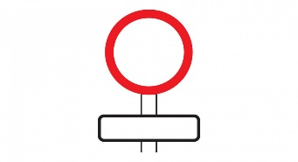  UK –Only bicycles being pushed

