Quiz 43 Straight 1 point each.
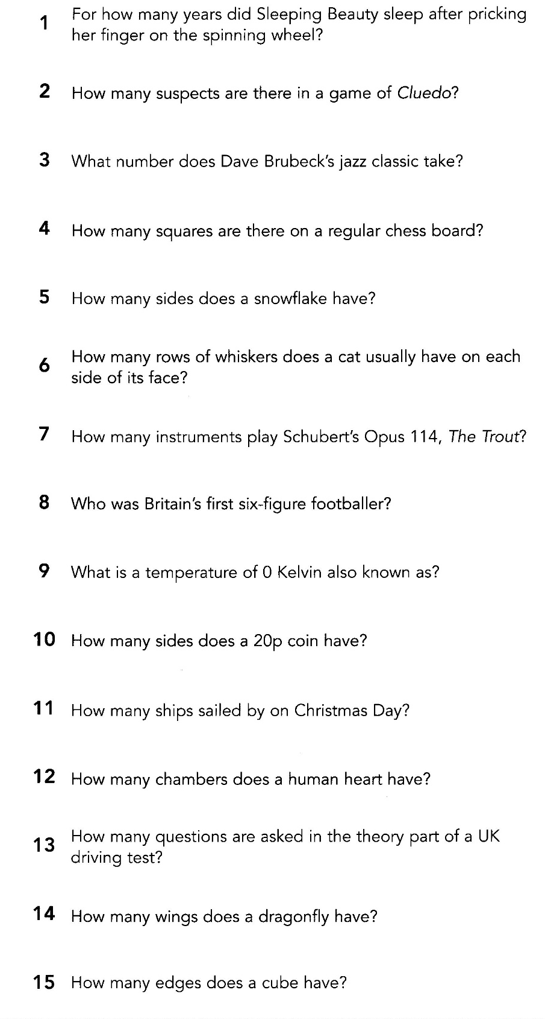

Quiz 47
N.B In Q 14 Ignore the extra point part.
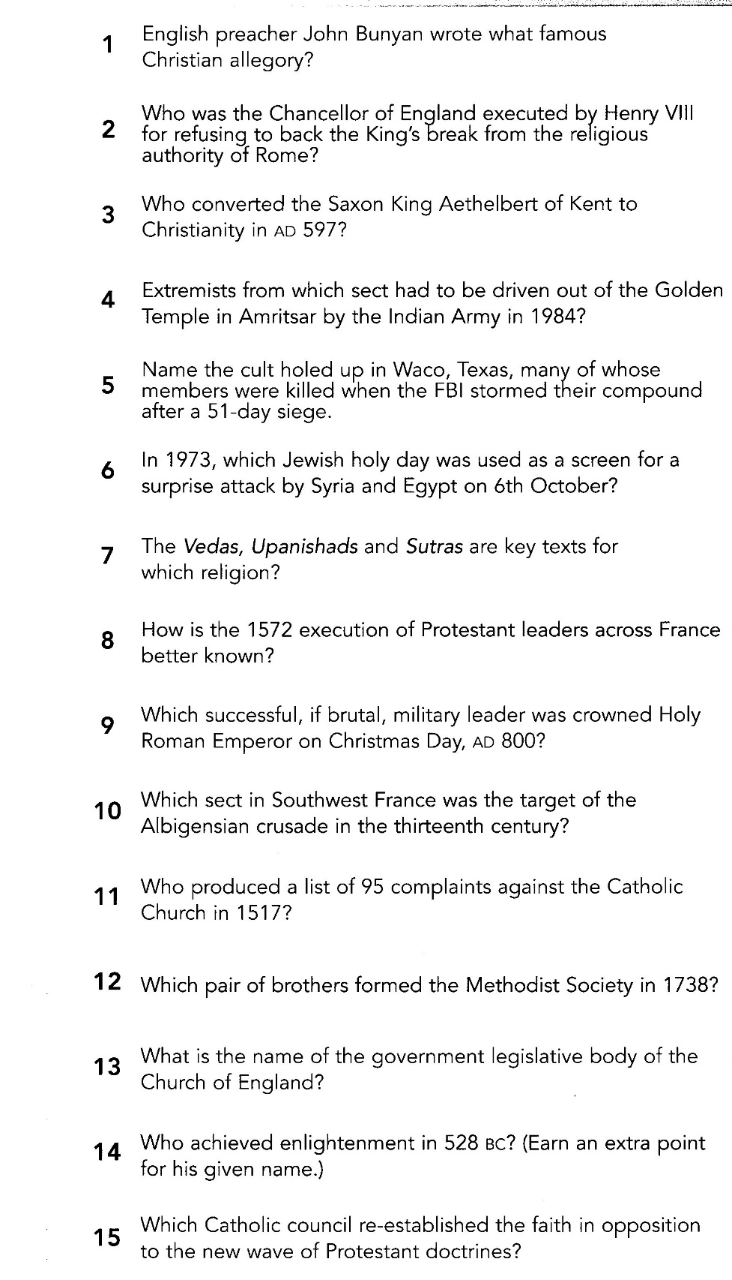

Quiz 28
In this quiz please note
Q2, ignore the nickname part of the question
Q8, Just the parents names
Q12 Either the dog OR the puppy for a point
Q19 just the butler’s name
